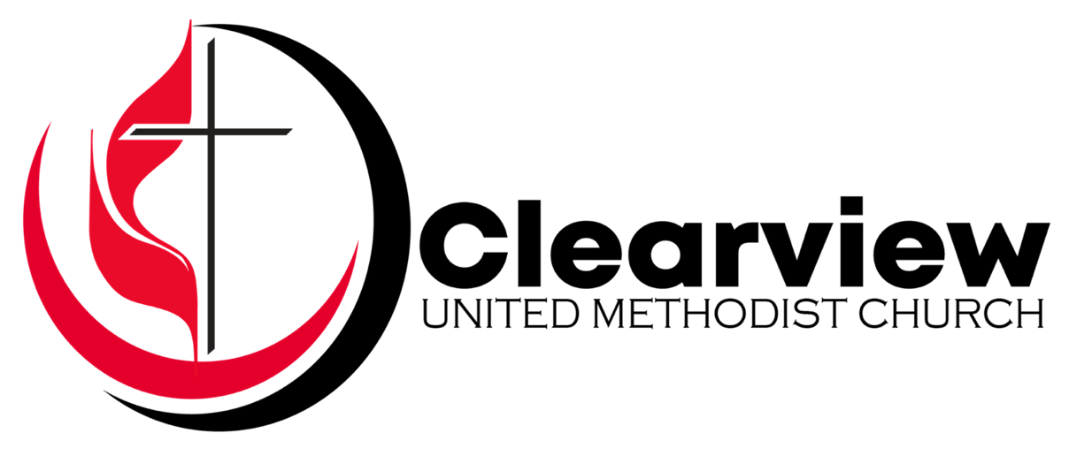

**September 24, 2023**

9:30 am Worship • Sanctuary & Online

**WORSHIP GUIDE**

**WELCOME**

Welcome to Clearview United Methodist Church. Each and every week we look forward to this time to gather as a community. We are glad YOU are here today with us!

You can use this worship guide to help lead through worship and throughout the week. We truly hope you enjoy your time here this morning and hope you return soon.

**Some logistics you may find helpful:**

* Masks are **OPTIONAL** on campus.
* Worship runs about an hour, sometimes a bit shorter & sometimes a bit longer.
* Grab a nametag from the table in the East Wing. If you are a guest, our Hospitality Team will happily make one for you.
* Childcare is available for non-school-aged children (6 wks through 4 yrs) in the nursery at the right of the front of the sanctuary. Children in Grades K through 5 are invited to worship until after the Children’s Moment and then can go to Sunday School in the Care & Share Room.
* A restroom is in the Care & Share Room to the right of the front of the Sanctuary. There are additional restrooms outside in the courtyard.
* Prayer Cards are available in the pew in front of you and at all entrances. Please place your prayer card in the offering plate or a prayer box. It is our joy and privilege to be praying with and for you.
* We have several ways you can give financially to support the mission of Clearview.

1. Place cash/check in the offering plate/boxes or mail to the church.
2. Text any amount to (727) 513-5557.
3. Visit clearviewumc.org/give.
4. Use your bank’s bill payer system.

* For more information, visit our website (clearviewumc.org).

**OUR MISSION**

*This is the reason we exist as a church:*

**Living an embodied faith, sharing God’s love for all.**

**OUR VALUES**

*These concepts define who we are, what we are committed to,*

*and how we participate in community together: We are…*

**Caring and Compassionate**

**Serving-focused**

**Community-focused**

**Kingdom-minded**

**Open-minded**

**Team-based**

**Innovative**

**OUR RHYTHM OF LIFE & TRANSFORMATION**

*This rhythm moves us toward individual and communal transformation:*

**Look Up** to God • **Look In** to Ourselves • **Look Out** to our community

**OUR VISION**

*How we see God’s preferred future lived out:*

**God’s love reaches Saint Petersburg and beyond.**

**HOW IT ALL WORKS TOGETHER**

As we are ***living an embodied faith, sharing God’s love for all***;

being guided by our ***values***;

and becoming people who ***Look Up, Look In and Look Out***;

the Holy Spirit will fulfill the vision where,

***God’s love reaches Saint Petersburg and beyond***.

**ORDER OF WORSHIP**

*UMH: The United Methodist Hymnal • TFWS: The Faith We Sing • *please stand as you are able*

**WE GATHER**

**CALL TO WORSHIP**

**WELCOME**

**\*WORSHIP MUSIC**

*How Great Is Our God*

**WE PROCLAIM**

**\*AFFIRMATION OF FAITH**

*A Statement of Faith of the United Church of Canada* (UMH #883)

**\*GLORIA PATRI**

*Glory Be To The Father* (UMH #71)

**PRAYER**

*The Lord’s Prayer* (UMH #895)

**\*PASSING OF THE PEACE**

**\*WORSHIP MUSIC**

*Goodness of God*

**\*PRAYER FOR ILLUMINATION**

**SCRIPTURE READING**

*Genesis 32:9-13 & 22-30*

**CHILDREN’S MOMENT**

**MESSAGE**

**WE RESPOND**

**OFFERING**

**\*DOXOLOGY**

*Praise God, From Whom All Blessings Flow* (UMH #95)

**WE GO OUT**

**\*WORSHIP MUSIC**

*Reckless Love*

**\*BENEDICTION**

**THIS WEEK’S PRAYER GUIDE**

|  |  |
| --- | --- |
| Sunday • Sept 24 | Victims of Catastrophic Flooding in Libya |
| Monday • Sept 25 | Victims of Moroccan Earthquake |
| Tuesday • Sept 26 | End to Multiple Terrorist Insurgencies Around the World |
| Wednesday • Sept 27 | Peace in Ukraine |
| Thursday • Sept 28 | Victims of Human Trafficking |
| Friday • Sept 29 | Victims of U.S. Mass Shootings (508+ in 2023) |
| Saturday • Sept 30 | Victims of Wildfires Burning in Siberia, U.S., Arctic, Brazil, Indonesia, Argentina, Canada, and Australia |

**New September 24th:** Carmalynn Bonelli-passed away 9/17 in Mease Hospital, prayers and sympathies for family and friends (M.Strid); Codee Gilbert & Teaching Team-prayers for successful teaching year in spite of team changes, packed classrooms and children’s behavioral issues; Lori Miley-neurosurgery, prayers for healing and comfort (friend-C.Berg); Sandy Morneault-prayers for peace and comfort while adjusting to life changes.

**New September 17th:** David Homsher-passed on 9/5; many prayers and sympathies for his family and friends; Lynne Rogers-serious health issues, prayers for healing and comfort (sister-L. Davis); Judy Stallard, sympathies and prayers for family and friends on her passing in TN on 9/12 (T. Glick).

**Ongoing**: Fred Ames Family, Crystal Anderson, Elaine Billings, Carolanne & Eric Blonshine, Cassie Brown, Lisa Chamberlain, Norm Chamberlain Family, Jean Daddis, Delores Davis Family, Tim Deacon, Robert Eldred, Bill & Lois Godfrey, Brian Goude, Phyllis Greenwood, Juanita Groves Family, Rycky Hollimon, Jacob (& family), Paul & Laurietta Lewis, Dorothy Light, Eric Hinkle, Ruth & Wen Hockersmith, Elizabeth Holmes, JeanAnn, Barbara Kanost, Larry Kinney, Carolyn McGovern, Bertis & Don McMillan, Karen Davis Noel Family, Kirstin Owens, George Roth Sr., Lynda Waite, Keith Winchell (and Diane), Phyllis Zwick, Pastor Erick Ashley & Family, Clearview UMC & Leadership, our country and leaders.

**Military**: Seth Crist & Family, Sam Godin, Casey Linde-Powers, George Roth & Family.

**Our Mission Partners**: Our sister church in Cuba: Iglesia Metodista de Guareiras – Matanzas Cuba District; FL Dream Center; Florida United Methodist Children’s Home, Zoe Empowers Abishyizehamwe “Togetherness” Group in Rwanda.

**WHAT’S HAPPENING AT CLEARVIEW?**

**It's Time to Decorate the Pumpkin Patch!**

Please help decorate the Patch on **Saturday, Sept 30, at 9 am**. A lot of help is needed to transform the empty pavilion and plain old field into a welcoming, fun, adventurous pumpkin place. Questions? Don't hesitate to contact Cassie Berg (215-479-9037 or [Bergcassie60@gmail.com](mailto:Bergcassie60@gmail.com)).

**The Pumpkins Are Coming & We Need Your Help!**

Saturday, Oct 7 is our first delivery of pumpkins for the season. Our annual Pumpkin Patch will be open from Oct 7 through Oct 31 or until the last pumpkin is sold!

We need your help unloading the pumpkins and staffing the patch for the month. You can sign up for your shifts online at [**clearviewumc.org/pumpkins**](http://www.clearviewumc.org/pumpkins). This year, we are trying an online-only volunteer sign-up. We will set up some computers in the East Wing for you to use before or after worship. We will also have some people there to assist you should you need some help. You can also contact the Church Office for assistance or grab a tech-savvy friend or family member.

We need cashiers, pumpkin pricers, greeters, and pumpkin turners. There is a place for everyone to serve regardless of age or strength. Come hang out in the patch and share the love of God with our community!

**The Bloodmobile Results**

Thank you for being so supportive of last week’s blood drive. Our goal was five participants, and we had four. Together, we donated five units (3 whole blood units & 2 red blood cell units). Please mark your calendar for Jan 21 and plan to give the gift of life that day.

**The Great American Teach-In at Lealman Avenue Elementary**

The Great American Teach-In is a part of Pinellas County Schools’ annual American Education Week celebration. It is a special opportunity to visit Lealman Avenue Elementary and share your knowledge and experience with a new generation. The 2023 event is scheduled for Wednesday, Nov 15. Opportunities are available from 9 am to 2:30 pm, and you may choose to spend 30 minutes, a couple of hours, or the entire day. Your schedule and the teachers’ needs determine the amount of time you volunteer. Whatever the length of your visit, you can make a difference. And, as thousands of previous Teach-In participants have discovered, the experience is truly rewarding. Information and sign-up sheets are available in the East Wing. Please contact Angela Malykhin (570-3020 or [malykhina@pcsb.org](mailto:malykhina@pcsb.org)), for more details.

**THE WEEK AHEAD**

**SUNDAY, Sept 24**

* **Worship**, 9:30 am – Sanctuary & Online
* **Childcare** (6 wks-4 yrs),9:30 am– Nursery
* **Mid-Service Children’s Sunday School** (K-5), 10 am – Care & Share Room
* **Coffee & Conversation**, 10:45 am – Care & Share Room

**MONDAY, Sept 25**

* **Alfred Adler School,** 8 am-3 pm
* **Boy Scout Troop #334**, 6 pm – Scout House & Pavilion
* **BS (BIBLE STUDY),** 6:45 pm – Care & Share Room
* **Alcoholics Anonymous (Common Solution)**, 7 pm – Module #32
* **Alcoholics Anonymous (Gratitude)**, 8 pm – Fellowship Hall & Room 11

**TUESDAY, Sept 26**

* **Alfred Adler School,** 8 am-3 pm
* **Alcoholics Anonymous (Fe y Esperanza)**, 8 pm – Module #31
* **Alcoholics Anonymous (Recovery Begins)**, 8 pm – Fellowship Hall

**WEDNESDAY, Sept 27**

* **Alfred Adler School,** 8 am-3 pm

**THURSDAY, Sept 28**

* **Alfred Adler School,** 8 am-3 pm
* **Alcoholics Anonymous (Serenity, Back to the 40s)**, 11 am – Module #31
* **Alcoholics Anonymous (A Clear View to the Big Book)**, 6:30 pm – Module #32

**FRIDAY, Sept 29**

* **Alfred Adler School,** 8 am-3 pm
* **Alcoholics Anonymous (Common Solution)**, 7 pm – Module #32
* **Alcoholics Anonymous (Fe y Esperanza)**, 8 pm – Module #31

**SATURDAY, Sept 30**

* **Adopt-A-Block Food Distribution**, 9 am – Pavilion & Field

**SUNDAY, Oct 1 – World Communion Sunday**

* **Worship**, 9:30 am – Sanctuary & Online
* **Childcare** (6 wks-4 yrs),9:30 am– Nursery
* **Mid-Service Children’s Sunday School** (K-5), 10 am – Care & Share Room
* **Coffee & Conversation**, 10:45 am – Care & Share Room

**MARK YOUR CALENDAR**

|  |  |  |
| --- | --- | --- |
| Oct 7 | Pumpkin Delivery (many volunteers needed) | 8 am |
| Oct 7 | Pumpkin Patch Opens | 9 am |
| Oct 14 | Pumpkin Delivery (many volunteers needed) | 8 am |
| Oct 15 | 2023 Charge Conference | 4 pm |
| Oct 21 | Pumpkin Delivery (many volunteers needed) | 8 am |
| Oct 21 | Pumpkins, Picnic & Pictures Event | TBD |

**Clearview United Methodist Church**

4515 38th Ave N

St. Petersburg, FL 33713

(727) 522-4673 • [admin@clearviewumc.org](mailto:admin@clearviewumc.org)

Office Hours: Monday-Thursday • 9 am-1 pm

Pastor Erick is available by appt. on Sundays-Thursdays

Pastor – Rev. Erick Ashley – [pastor@clearviewumc.org](mailto:pastor@clearviewumc.org)

Church Administrator – Diana Wells – [admin@clearviewumc.org](mailto:admin@clearviewumc.org)

Custodian – Steven Brinkley – [admin@clearviewumc.org](mailto:admin@clearviewumc.org)

Bishop of the Florida Annual Conference – Rev. Tom Berlin

Gulf Central District Superintendent – Rev. Emily Hotho